Go Green (er) for Lent – resources from Arocha / Wild Christian

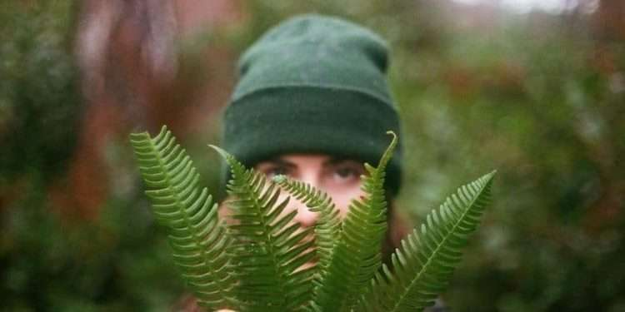

How can we become better at caring for creation and improving our lives and the lives of others through healthy, eco-friendly and sustainable living?
The Lenten 40-day period before Easter gives us the opportunity to reflect on the practice of fasting and commit to giving up something that brings a real benefit to nature and helps address climate change. Below are some changes you could make that will help the environment. Take time to pray, reflect and consider these options – pick one or two or however many you’d like (you never know the changes might just stick!)
- Go plastic free. Even if you can’t become totally plastic-free, make it your goal to at least reduce your use of plastic. Read Tom’s month without plastic blog here.
- Switch off from digital. Explore technology-free times or areas of the house, switching to ‘airplane mode’ for the first hour in the morning and the last hour at night, ‘switch off Sundays’, reaching for your Bible over your device(s) and writing a list of outdoor things that you enjoy.
- Boycott fast fashion. Emily reflects on how our clothes can bring us closer to our neighbour and have a lesser impact on nature. Read her blog here.
- Buy less or second hand. Read here how mum of 2, Nic started with small changes: using Facebook marketplace and ebay more to invest in second hand clothing and toys.
- Buy local or in bulk. Hannah shares how learning more about our food system has impacted what her and her family choose to consume. Read her blog here.
- Become zero waste. Slowly try to reduce your waste a bit every week. Consider giving a home-made gift instead of buying a present, upcycling items or looking at your food shop and seeing what items you could buy differently, spending a bit more on loose fruit and veg for example.
- Spend more time in nature. With weekly themes, these ‘Get Outside in Lent’ outdoor resources profiled in our Eco Church resources will help you connect with God as Creator and celebrate his creation in different ways over the Lenten period.
- Invite wildlife into your garden or church green space (with permission!). Read John’s tips on greening our gardens for nature’s benefit here. Where possible, invite and encourage others in your church community to be part of the journey, for example, planting seeds as part of the children’s ministry or getting your church youth group to help build and stock up a hedgehog home.
- Try a plant-based recipe or diet. Start by cooking yourself vegan or plant-based meals once a week and take it from there. As time goes on, cook more vegan/vegetarian meals and try to eliminate as many animal products from your diet as you can. Explore tasty recipes with Meat Free Monday or read about Kayleigh’s veganuary experience here.
- Grow your own. Whether you have a garden or sunny windowsill, find out what you can sow and grow on a month-to-month basis here. Read how Vishadhi is using her home-grown food to bless her local community and food bank here.
- Change your method of transport. How about walking or cycling for repeated errands, choosing one day a week to walk, cycle or take public transport to work where you are able to. Read about how Paul and his wife, Tara are changing the way they travel (and more!) here.
- Take a step to save energy in your home. From draught-proofing windows and doors to swapping your bath for a shower, here’s a list of quick tips. You might be surprised at how many of these changes you’ve already made!
- Move your money. Could you divest from fossil fuels and support a bank which invests in renewables? ‘Good with Money’ recommends some ethical choices here or for pension investments that help achieve the 17 Sustainable Development Goals set by the UN in 2015 there’s ‘Make my Money Matter’.
- Join the movement for fossil free Churches. Start the conversation in your local church to make a commitment to divest. Speak with your church minister or treasurer, and ask if the issue could be discussed at your next church council or PCC meeting. See the Bright Now campaign website for further information and guidance.
- Join the Eco Church community. Make a commitment to long term action on the environment in your local community through Eco Church or other greening schemes. If you’re already part of an Eco Church, find out how you can help your church achieve the next award level.
Where do I start?
We are all different: what matters is that you take the first step. So choose a change to make – be gentle on yourself and realistic – but challenge yourself too!
One first action could be to calculate your carbon footprint. Use Climate Stewards’ carbon footprint calculator and consider one (or two) of the tips on how you can reduce your footprint.
And finally, we say… enjoy creation! We’ve made a list of ways to enjoy nature here.
Share your green lent journey by tagging us on social media.
Sign up to our free Wild Christian regular email for practical ways to enjoy, nurture and defend nature here.
Explore our Eco Church resources here.

