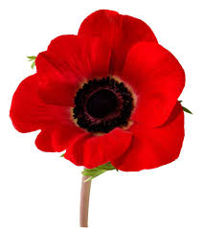Lest We Forget

Everyone is invited to share in making a poppy wall outside St Mary’s Church 7-14th November to mark 75th Anniversaries of VE and VJ days and 80th Anniversary of the Battle of Britain.
Poppies can be of all shapes and sizes. It could be a traditional Royal British Legion one, a knitted one or a home made one in fabric, felt, clay or recycled material.
A knitting pattern is available from Jean at jss42@icloud.com, or direct from the Royal British Legion web site and many other sources.
There will be a box behind St Mary’s front wall to put your poppies in, near the noticeboard, from 1st November. We will mount the display on Saturday 7th November but please feel free to add your own poppies from then on.
Together we will not forget the sacrifice of so many during the nation’s conflicts. Join with family, friends and neighbours in this shared Act of Remembrance.
http://branches.britishlegion.org.uk/branches/arnold/remembrance/knitted-poppies

