Hymns for Worship: Thursday 21st May Ascension Day

Introductory music
Tune: Chislehurst, by Sir Sydney Nicholson
for ‘Hail the day that see him rise.’

Hail the day that sees him rise
Hail the day that sees him rise, Alleluia!
To his throne above the skies; Alleluia!
Christ, the Lamb for sinners given, Alleluia!
Enters now the highest heaven. Alleluia!

Still for us he intercedes, Alleluia!
His prevailing Death he pleads; Alleluia!
Near himself prepares our place, Alleluia!
He the first-fruits of our race. Alleluia!

Lord, though parted from our sight, Alleluia!
Far above the starry height, Alleluia!
Grant our hearts may thither rise, Alleluia!
Seeking thee above the skies. Alleluia!

(Charles Wesley, 1707 – 1788, Thomas Cotterill, 1779 – 1823, Tune: Llanfair and others)

Rejoice, the Lord is King!
Rejoice, the Lord is King!
your Lord and King adore;
mortals give thanks and sing,
and triumph evermore.
Lift up your heart, lift up your voice,
Rejoice again, I say, rejoice.

Jesus the Saviour reigns,
the God of truth and love;
when he had purged our stains,
he took his seat above. Lift up your hearts …

His kingdom cannot fail;
he rules o’er earth and heaven;
the keys of death and hell
are to our Jesus giv’n. Lift up your hearts …

He sits at God’s right hand
till all his foes submit,
and bow to his command,
and fall beneath his feet. Lift up your hearts …

(Charles Wesley, 1707 – 1788)

Before the throne of God above
Before the throne of God above,
I have a strong and perfect plea,
a great High Priest whose name is Love,
who ever lives and pleads for me.
My name is graven on his hands,
my name is written on his heart.
I know that while in heav’n he stands,
no tongue can bid me thence depart,
no tongue can bid me thence depart.

Behold him there, the risen Lamb,
my perfect, spotless righteousness,
the great unchangeable I AM,
the King of glory and of grace!
One with himself I cannot die.
My soul is purchased by his blood!
My life is hid with Christ on high,
with Christ my Saviour and my God,
with Christ my Saviour and my God.

(Charitie Lees Bancroft, 1841 – 1923)

Laudate Dominum (sung three times)
Laudate dominum, laudate dominum, omnes gentes, alleluia! (repeat)
[Sing praise and bless the Lord, sing praise and bless the Lord, peoples, nations, alleluia!]

Christ triumphant, ever reigning
Christ triumphant, ever reigning,
Saviour, Master, King.
Lord of heav’n, our lives sustaining,
hear us as we sing:
Yours the glory and the crown,
the high renown, the eternal name.

Word incarnate, truth revealing,
Son of Man on earth!
Pow’r and majesty concealing
by your humble birth: Yours the glory …

Suff’ring servant, scorned, ill-treated,
victim crucified!
Death is through the cross defeated,
sinners justified: Yours the glory …

Priestly King, enthroned for ever
high in heav’n above!
Sin and death and hell shall never
stifle hymns of love: Yours the glory …

So, our hearts and voices raising
through the ages long,
ceaselessly upon you gazing,
this shall be our song: Yours the glory …

(Michael Saward, 1932 – 2015)
Concluding music
Hail Redeemer, King divine, Priest and Lamb, the throne is thine; King, whose reign shall never cease, Prince of everlasting peace. Angels, saints and nations sing: ‘Praised be Jesus Christ our King; Lord of life, earth, sky and sea, King of love on Calvary.

King, whose name creation thrills, rule our minds, our hearts, our wills, till in peace each nation rings with thy praises, King of kings. Angels, saints and nations sing: ‘Praised be Jesus Christ our King; Lord of life, earth, sky and sea, King of love on Calvary.
Patrick Brennan, 1877 – 1952

Hymns reproduced under CCL Licence 300015 and 556058
Readings

A reading from the Acts of the Apostles
Acts 1: 1 – 11

In the first book, Theophilus, I wrote about all that Jesus did and taught from the beginning until the day when he was taken up to heaven, after giving instructions through the Holy Spirit to the apostles whom he had chosen.

After his suffering he presented himself alive to them by many convincing proofs, appearing to them during forty days and speaking about the kingdom of God. While staying with them, he ordered them not to leave Jerusalem, but to wait there for the promise of the Father.
“This,” he said, “is what you have heard from me; for John baptized with water, but you will be baptized with the Holy Spirit not many days from now.”

So when they had come together, they asked him, “Lord, is this the time when you will restore the kingdom to Israel?” He replied, “It is not for you to know the times or periods that the Father has set by his own authority. But you will receive power when the Holy Spirit has come upon you; and you will be my witnesses in Jerusalem, in all Judea and Samaria, and to the ends of the earth.” When he had said this, as they were watching, he was lifted up, and a cloud took him out of their sight. While he was going and they were gazing up toward heaven, suddenly two men in white robes stood by them.
They said, “Men of Galilee, why do you stand looking up toward heaven? This Jesus, who has been taken up from you into heaven, will come in the same way as you saw him go into heaven.”

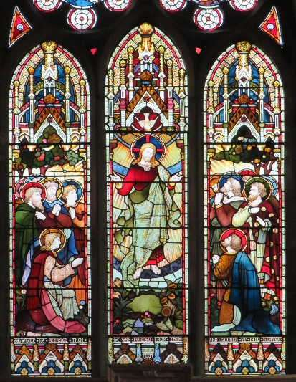

Psalm 47

God has gone up with a triumphant shout, the Lord with the sound of the trumpet.

Clap your hands, all you peoples; shout to God with a cry of joy.
For the Lord Most High is to be feared; he is the great King over all the earth.

God has gone up with a triumphant shout, the Lord with the sound of the trumpet.

He subdues the peoples under us, and nations under our feet.
He chooses our inheritance for us, the pride of Jacob whom he loves.

God has gone up with a triumphant shout, the Lord with the sound of the trumpet.

God has gone up with a triumphant shout, the Lord with the sound of the trumpet.
Sing praises to God, sing praises; sing praises to our king, sing praises.

God has gone up with a triumphant shout, the Lord with the sound of the trumpet.

For God is king of all the earth; sing praises with all your skill.
God reigns over the nations; God sits upon his holy throne.

God has gone up with a triumphant shout, the Lord with the sound of the trumpet.

The nobles of the peoples have gathered together with the people of the God of Abraham.
The rulers of the earth belong to God, and he is highly exalted.

God has gone up with a triumphant shout, the Lord with the sound of the trumpet.

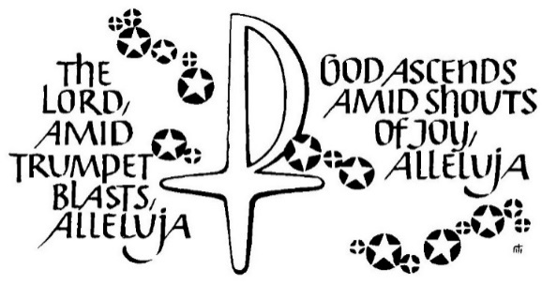
Readings reproduced under CCL Licence 300015 and 556058

