The Churches of St Mary, Haxby and St Nicholas, Wigginton
The United Benefice of Haxby and Wigginton
Stepping out … with God … with each other … with our local community and wider world
_____________________________________________________________________

Worship: 17th May 2020
The Sixth Sunday of Easter
Gathering prayer
God of all the Earth, be present with us now, in each of our homes, as we connect together. Build us into a spiritual house, a holy priesthood,
offering spiritual sacrifices acceptable to you through Jesus Christ, our risen redeemer and healer. Amen.

Opening hymn ‘Father I place into your hands’
You may like to light a candle if it is safe to do so.
This Christian Aid Week, the hands of many of us have been far from idle. Though not handing out envelopes or hosting Big Brekkies or the many things we usually busy ourselves with this week, our hands can still reach out virtually to our neighbours around the world. Neighbours in refugee camps and cramped living conditions, neighbours without adequate hand-washing facilities, neighbours who face the devastating impact of coronavirus with even less of the medical resources we have struggled to access here.

Look at your hands. Our hands are the most remarkable and useful tools, involved in so much of what we do and how we do things, even in these days of social distancing. Pause and offer the work of your hands to God. However your hands look to you, they are probably very clean with regular hand washing as we work together to prevent spreading coronavirus. We are also extra aware of things our hands touch when something comes from outside our own home.

Prayer of Confession
As we turn on the tap, we turn our hearts towards you, O God.
As we wet our hands renew our thoughts, so we might be transformed.
As we lather soap between fingers and over all our hands, purge from us all that brings us harm and might harm others.
Remove the invisible guilt and shame that so often keeps us from you.
As we rinse our hands, we trust in your overflowing grace,
making all things new. Amen.

The Bible readings and Psalm can be found on the separate sheet with the hymn words.

Old Testament Reading Genesis 8: 20 – 9: 17

Psalm Psalm 31 (vv1-5, 15-16)

Time for reflection
If you have time to read the whole psalm, you will see that the psalmist expresses many emotions – you may have experienced some of these during this uncertain and difficult time. Are there any words or phrases that particularly catch your attention?

‘Let us build a house where hands will reach …’ (see hymn words sheet)

Gospel John 14: 15 – 21

Sermon (by The Ven Chris Hawthorn)
Provided on the benefice website. You may like to listen to it now, or later.

Second hymn ‘Jesus lives! thy terrors now …’
Response
We might long to hold the hand of a person we can no longer touch. We pray for the hands of medics to bring healing and comfort. We are grateful for hands stacking shelves, and the hands delivering groceries and post.

Let us pray together using our open hands.

Intercessions (prepared by Rob Calvert)
Our intercessions begin with a prayer from Christian Aid.

God our refuge, we come to you with open hands, some of us with hearts full of questions, some of us bruised by bereavement, some of us fearful for what the future holds, all of us stunned by the events of this year. Draw close to us now, in each of our homes as we place our honest questions and hopes into your open, resurrected yet scarred hands.
Lord, in your mercy, hear our prayer.

We give thanks for the work of Christian Aid and its partners around the world as they bring hope into the lives of many thousands of people who are in desperate need, often in situations where there is no peace, justice or security, and we pray for a generous response to their appeal for funds.

We pray for the nations of the world, that we will be ready to co-operate with each other to bring the coronavirus pandemic under control, especially in countries which are least able to protect themselves. Let us be ready to share our knowledge, expertise and money for the good of all.
Lord, in your mercy, hear our prayer.

Jesus said, ‘Because I live, you too will live’. He showed us how to be a caring community, and we give thanks for the many acts of kindness which bring comfort into people’s lives.
This crisis has shown that there is a deep well of love for one another, which is being drawn on daily and shared freely. We pray that through prayer and practical action, God’s love for his world will continue to flow as a life-giving stream, bringing life to all.
Lord, in your mercy, hear our prayer.

This coming week is Mental Health Awareness Week.
Jesus our Healer, we pray for people who are anxious, depressed and fearful for their future, and for the NHS and community care staff who support them. We pray for members of our Church Family who are ill, for those in hospital, and for their families and friends who are distressed by not being able to visit them (see intercessions list).

We pray for those who have died this week, and for families and friends who are in the depths of grief (see intercessions list). Lord Jesus, hold them close, give them comfort and bring them to a time of peace.
Lord, in your mercy, hear our prayer.

The Lord’s Prayer
Our Father in heaven, hallowed be your name,
your kingdom come, your will be done, on earth as in heaven.
Give us today our daily bread.
Forgive us our sins as we forgive those who sin against us.
Lead us not into temptation but deliver us from evil.
For the Kingdom, the power and the glory are yours,
now and forever. Amen

Third Hymn ‘Be thou my vision’

As we go and, possibly, wash our hands again,
Let us say our blessing together:

May the presence of the Creator refresh you,
may the comfort of the Son renew you,
may the inspiration of the Spirit restore you
to be love in action, even from a distance,
in our neighbourhoods, near and far, this day and for evermore.
Amen.

Text: Christian Aid and other sources; reproduced under CCL Licence 300015 and 556058

Closing offering
If you wish to make a donation to Christian
Aid, you can do so online at caweek.org/payin
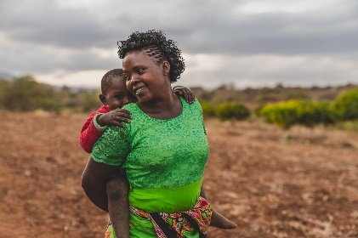
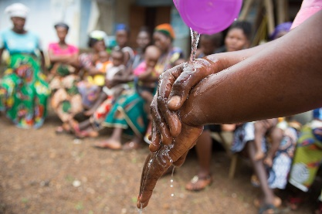

Faith Muvili with her son in Kenya.
Credit: Christian Aid / Adam Finch

A hand-washing clinic run by Judith Lassie in the village of Sawula, Sierra Leone. Credit: Christian Aid / Tom Pilston

